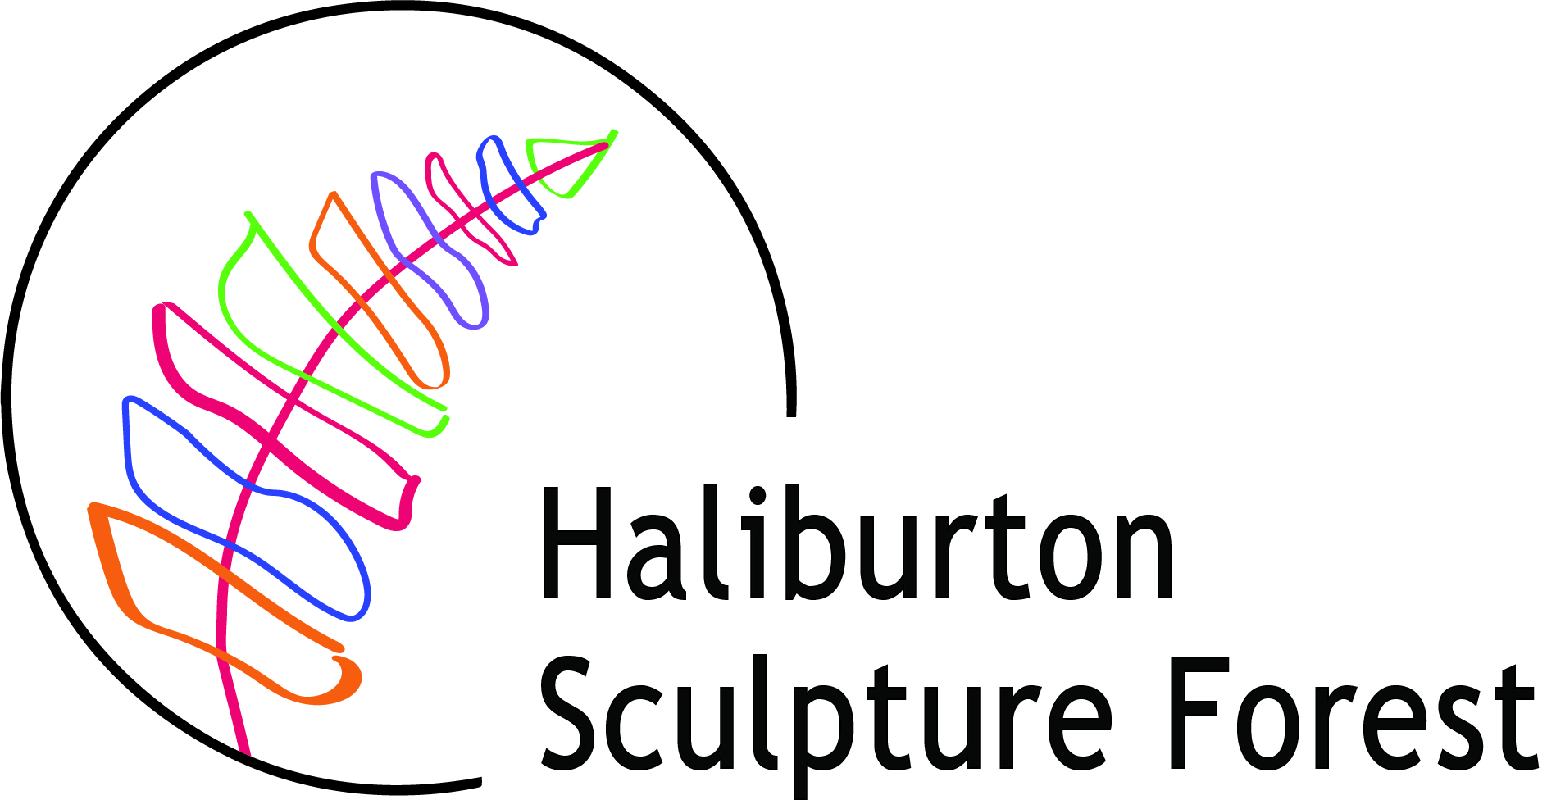

DOWNTOWN HALIBURTON SCULPTURE EXHIBITION 2022
OFFICIAL ENTRY FORM
Deadline for entry – 5:00 pm May 6th, 2022

Artist Name_____________________________________________________
Address ________________________________________________________
City______________________________________ Postal Code____________
Phone______________________________ Alt. Phone___________________
Email Address ___________________________________________________
Website ________________________________________________________
Attach a single page artist CV if you wish.
Submission #1
Title____________________________________________________________
Medium_________________________________________________________
Height_______Width_______Depth________(in inches) Weight (est.)_________ (in lbs.)
Images Info______________________________________________________
Submission #2
Ttile____________________________________________________________
Medium_________________________________________________________
Height_______Width_______Depth________(in inches) Weight (est.)_________ (in lbs.)
Images Info_______________________________________________________

Please submit:
- Completed, signed application form, maximum of two entries.
- Images or drawings each labelled with your name and title of work.
- Send images as separate jpeg files
- Sculpture descriptions and narratives (100 words max), including any pertinent information regarding your vision or concept of the work.
- Single page CV (optional).
By completing this Entry Form I acknowledge that:
I have read and agree to the Exhibition Guidelines.
- Images of selected artwork may be used to promote the Downtown Haliburton Sculpture Exhibition without further agreement and without compensation to the artist.

Signature_________________________________ Date________________

